**GUIDELINES FOR MASTER'S THESES**

Center of English Language

Isfahan University of Technology

# Appendix

The sample manuscript starts on the next page. Follow the sample pages exactly.

* Manuscripts are to be produced using Microsoft Word.

**The correct spelling of professors’ name.**

**1-Dr. Gholam Reza Zarei**

**2-Dr. Hassan Jalali**

**3-Dr. Meisam Rahimi**

**4-Dr. Saeed Ketabi**

**5-Dr. Zohreh Kashkoli**

**6-Dr. Momene Ghadiri Modares**

**7-Dr. Maedeh Ghavamnia**

**8. Dr. Fatemeh Zolfaghari**

**ساختار کلی پایان نامه به صورت نمونه در صفحات بعدی وجود دارد**

**لطفا موارد را با دقت مطالعه نموده و رعایت نمایید.**

**\*\*دقت کنید که در قسمت lay out قالب پایان نامه را برای چاپ A4**

**انتخاب نمایید**

**بسم الله الرحمن الرحیم**

**(B Zar centralized, boldface, 12)**



Isfahan University of Technology

Center of English Language

Title of the Thesis

______________________

A Thesis

Presented to

Center of English Language

Isfahan University of Technology

________________________

In Partial Fulfillment

of the Requirements for the Master’s Degree

in Teaching English as a Foreign Language

Supervisor: **Dr. ……………………..**

Advisor: Dr. ………………………..

By

Your Name

**Month, Year**

© Copyright by Isfahan University of Technology

All Rights Reserved



Isfahan University of Technology

Center of English Language

Title of the Thesis

--------------------------------------------------------------------------------------------------------------------------------------------------

**A thesis presented**

By

Your Name

Approved as to style and content by:

**Dr. Name Family Name, Supervisor**

**Dr. Name Family Name, Advisor**

**Dr. Name Family Name**, **Committee Member**

**Dr. Name Family Name**, **Committee Member**

Dr. Name Family, Department Head Center of English Language

Acknowledgments

Text text text text text text text text text text text text text text text text text text text text text text text text text text text text text text text text text text text text text text text text text text text text text text text text text. (Times New Roman, 12, 1.5 pt)

Dedication

Text text text text text text text text text text text text text text text text text text text text text text text text text text text text text text text text text text text text text text text text text text text text text text text text text. (Times New Roman, 12, 1.5 pt)

# Abstract

Abstract must be between 200 to 300 words Text text text text text text text text text text text text text text text text text text text text text text text text text text text text text text text text text text text text text text text text text text text text text tex text text text text text text text text text text text text text

**Keywords**: Text; Text; Text; Text; Text (between 5 to 7 words; Times New Roman, 12)

**Abstract باید بین 200 تا 300 کلمه باشد و منظور کامل پایان نامه را برساند کلید واژه ها بدون فاصله از متن اصلی باشد به صورت الفبایی مرتب شود و بین آنها نقطه ویرگول ; قرار داده شود. تعداد کلید واژه ها بین 5 تا 7 عدد باشد.**

Table of **Contents**

(Times New Roman, 12, 1.5 pt)

Title Page

Appendix 3

Acknowledgments v

Dedication vi

Abstract vii

List of Tables xi

List of Figures xii

List of Abbreviations xiii

Chapter One: Introduction

1.1. Background to the Study …………………………………...………………….……………... 1

* 1. Subheading 2 ………………………………………………………...………………………. 2
  2. Subheading 3 ……………………………………………………………………...…………. 3

Chapter Two: Literature Review

2.2. Overview ………………………………………………………………………………............9

2.2.1. Subheading1 …………………………………………………………… …………………………………………………….….9

2.2.2. Text text text text text text text text text text ………………………………………...…..10

2.2.3. Text text text text text text text text text text ………………………………………..…....11

2.2.4. Text text text text text text text text text text ………………………………………......... 13

2.3. Text text text text text text text text text text………………………………………..……......13

2.4. Text text text text text text text text text text ………………………………………………....16

2.4.1. Text text text text text text text text text text …………………………………………......18

Chapter Three: Methodology

3.1. Overview ……………………………………………………………………………………...30

3.2. Data Description …………………………………………………………………………...31

3.3. Text text text text text text text text text text …………………..……………………….….33

Chapter Four: Results

4.1. Overview ……………………………………………………………………………….......30

4.2. Data Description ………………………………………………………………………....….31

4.3. Text text text text text text text text text text…………………………………………….…33

4.4. Text text text text text text text text text text …………………………………………….....33

4.4.1. Text text text text text text text text text text ………………………………………......35

4.5. Summary ..……………………………………………………………………………….... .58

Chapter Five: Discussion

5.1. Overview ………………………………………………………………………………..….59

5.2 Restatement of the problem ………………………………………………………………...59

5.3. Discussion ……………………………………………………………………………….....60

5.3.1. Research Question 1 ………………………………………………………………........61

5.3.2. Research Question 2 ……………………………………………………………………62

5.3.3. Research Question 3 …………………………………………………………………....62

5.3.4. Research Question 4 ……………………………………………………………………64

5.3.5. Research Question 5 ……………………………………………………………………66

References ………………………………………………………………………………......66

Appendices………………………………………………………………………………….......66

List of Tables

Table 2.1. Caption for Table 1 (Times New Roman, 12, 1.5 pt)…………………………………..2

Table 2.3. Caption for Table 2 …………………………………………………………………….3

# List of Figures

Figure 1.3. Caption for Figure 1 (Times New Roman, 12, 1 pt)…………………………………..2

Figure 2.3. Caption for Figure 2 …………………………………………………………………..3

# List of Abbreviations

|  |  |
| --- | --- |
| WTC | Willingness to Communicate |
| TSIn | Teacher-Student Interaction |
| L2MSS | L2 Motivational Self System |

Chapter One

Introduction

## **1.1. Background to the Study**

Text text text text text text text text text text text text text text text text text text text text text text text text text text text text text text text text text text text text text text text text text text text text text text text text text text text text text text text text text text text text text text text text text text text text text text.[1]

Text text text text text text text text text text text text text text text text text text text text text text text text text text text text text text text text text text text text text text text text text text text text text text text text text text text text text text text text text text text text text text text text text text

## 1.1.1. Left, Boldface, Uppercase and Lowercase Heading (Times New R B 12)

1.Text text text text text text text text text text text text text text text text text text text text text text text text text text text text text text text text text text text text text text text text text text

text text text text text text text text text text text text text text text text text text text text text text text text text text text text.

1. Text text text text text text text text text text text text text text text text text text text text text text text text text t text text text text text text text text text text text text text text text text text text text text text text text text text text text text.ext text text text text text text text text text text text text text text text text text text text text text text text text text text text text text text text text text text text text text text text text
2. Text text text text text text text text text text text text text text text text text text text text text text text text text text text text text text text text text text text text text text text text text text text text text text text text text text text text text text text text text text text text text text text text text text.

## 1.2.Subheading 2

text text text text text text text text text text text text text text text text text text text text text text text text text text text text.

## 1.3.Subheading 3

text text text text text text text text text text text text text text text text text text text text text text text text text text text text.

Table 1

*Caption for Table 1*---------------------------------------------------------------------------------------------

|  |  |
| --- | --- |
| Header | Header |
| Text | (Times New Roman, 11, 1 pt) Text text text text text text text text text text text text text text text text text text text text text text text text text text. |
| Text | Text text text text text text text text text text text text text text text text text text text text text text text text text texttext text text text text text. |
| Text | Text text text text text text text text text text text text text text text text text text text text text text text text text text text text. |

Note. Xxxxx

**Level 2: Flush Left, Boldface, Uppercase and Lowercase Heading**

Text text text text text text text text text text text text text text text text text text text text text text text text text text text text text text text text text text text text text text text text text text text text text text text text text text text text text text text text text text text text text text text text text text text text text text.

**Figure 1 (Times New Roman, Bold; 12)**

Content Words in the Caption in Capital (Times New Roman, 12, Italics)

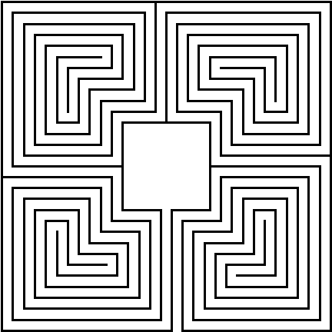

**Level 3:boldface, lowercase paragraph heading ending with a period** (Times New Roman12)

Text text text text text text text text text text text text text text text text text text text text text text text text text text text text text text text text text text text text *text* text text text text text text text text text text text text text text text text text text text text text text text text text text text text text text text text text.

**Level 4: boldface, italicized, lowercase paragraph heading ending with a period.** (Times New Roman, 12, bold)

Text text text text text text text text text text text text text text text text text text text text text text text text text text text text text text text text text text text text text text text text text text text text text text text text text text text text text text text text text text text text text text text text text text text text text text.

**Level 5: boldface,Text TextTextTextTextTextTextText.** (Times New Roman, 12, bold)

Text text text text text text text text text text text text text text text text text text text text text text text text text text text text text text text text text text text text text text text text text text text text text text text text text text text text text text text text text text text text text text text text text text text text text text.

Chapter Two

Literature Review

## 2.1. Overview

Text text text text text text text text text text text text text text text text text text text text text text text text text text text text text text text text text text text text text text text text text text text text text text text text text text text text text text text text text text text text text text text text text text text text text text

……….Text text text text text text text text text text text text text text text text text text text text text text text text text text text text text text text text text text text text text text text text text text text text text text text text text text text text text text text text text text text text text text text text text text

## 2.1.1.Subheading1

Text text text text text text text text text text text text text text text text text text text text text text text text text text text text text text text text text text text text text text text text text text text text text text text text text text text text text text text text text text text text text text text text text text text text text text

## 2.1.2.Subheading1

Text text text text text text text text text text text text text text text text text text text text text text text text text text text text text text text text text text text text text text text text text text text text text text text text text text text text text text text text text text text text text text text text text text text text text text

Chapter Three

Methodology

## 3.1. Overview

Text text text text text text text text text text text text text text text text text text text text text text text text text text text text text text text text text text text text text

……….Text text text text text text text text text text text text text text text text text text text text text text text text text text text text text text text text text text text text text text text text

Text text text text text text text text text text text text text text text text text text text text text text text text text text text text text text text text text text text text text text text text

Chapter Four

Results

## 4.1. Overview

Text text text text text text text text text text text text text text text text text text text text text text text text text text text text text text text text text text text text text text text text text text text text text text text text text text text text text text text text text text text text text text text text text text text text text text

Text text text text text text text text text text text text text text text text text text text text text text text text text text text text text text text text text text text text text text text text text text text text text text text text text text text text text text text text text text text text text text text text text text

Chapter Five

Discussion

## 5.1 Overview

Text text text text text text text text text text text text text text text text text text text text text text text text text text text text text text text text text text text text text text text text text text text text text text text text text text text text text text text text text text text text text text text text text text text text text text.

Text text text text text text text text text text text text text text text text text text text text text text text text text text text text text text text text text text text text text text text text text text text text text text text text text text text text text text text text text text text text text text text text text text

# 

# References (Times New Roman, 13, boldface)

***A Book***

Tabachnick, B. G., & Fidell, L. S. (2007). *Using multivariate statistics*. Pearson.

***A Chapter***

West, S. G., Finch, J. F., & Curran, P. J. (1995). Structural equation models with nonnormal variables: Problems and remedies. In R. H. Hoyle (Ed.), *Structural equation modeling: Concepts, issues and applications* (pp. 56-75). Sage.

***An article***

Velicer, W. F. (1976). Determining the number of components from the matrix of partial correlations. *Psychometrika, 41*(3), 321-327. <https://doi.org/10.1007/BF02293557>

***Published Dissertation or Thesis***

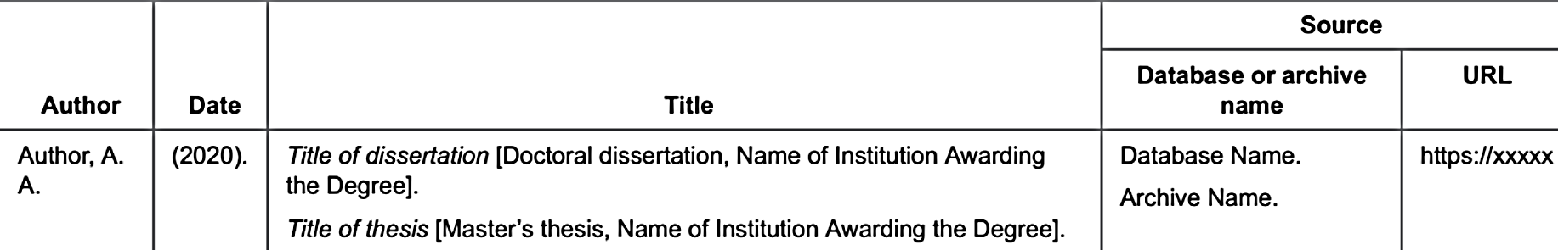

Zambrano-Vazquez, L. (2016). *The interaction of state and trait worry on response monitoring in those with worry and obsessive-compulsive symptoms* [Doctoral dissertation, University of Arizona]. UA Campus Repository. https://repository.arizona.edu/handle/ 10150/620615

***An unpublished thesis/dissertation***

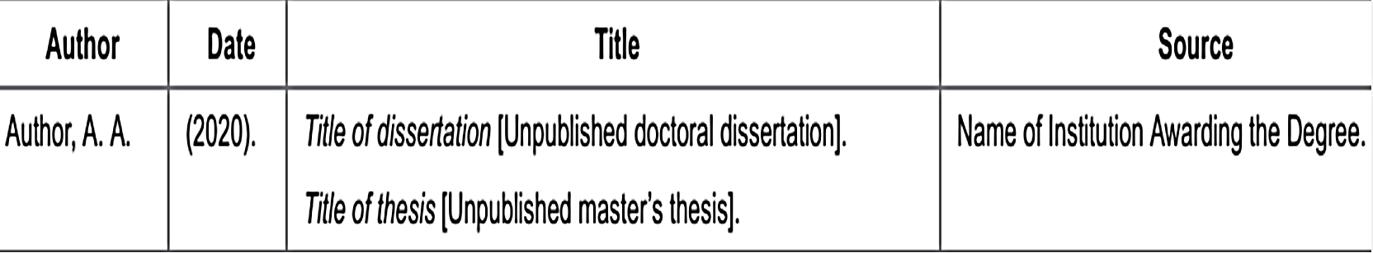

Hawkins, E. J. (1999). Artist and model: Shaping the creative process [Unpublished master's thesis]. James Cook University.

***Conference sessions or presentations***

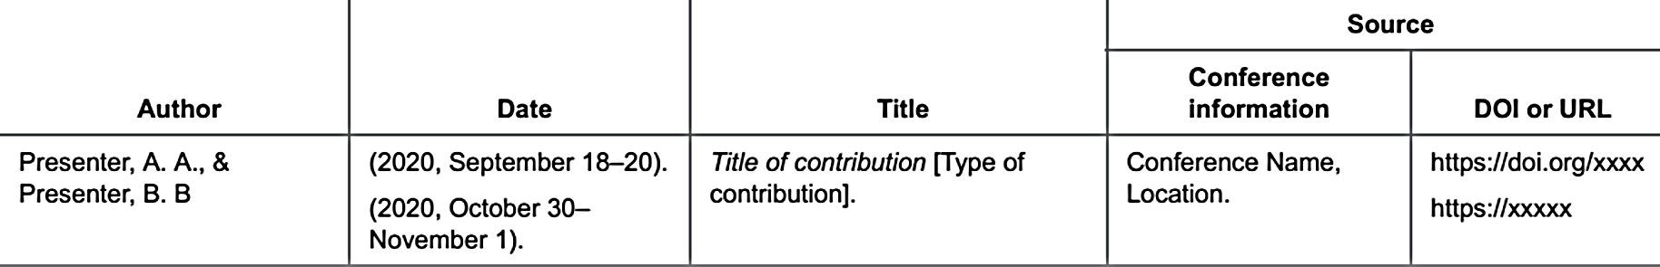

Cacioppo, S. (2019, April 25–28). *Evolutionary theory of social connections: Past, present, and future* [Conferencepresentation]. Ninety-ninth annual convention of theWestern Psychological Association, Pasadena, CA, United States. <https://westernpsych.org/wpcontent/uploads/2019/04/WPA-Program-2019-Final-2.pdf>

برای کسب اطلاعات بیشتر و رفرنس های متفاوتی که در اینجا ذکر نشده، به کتاب APA ادیشن هفتم مراجعه بفرمایید.

# APPENDIX A: TITLE OF APPENDIX A (Times New Roman, 13, boldface)

Text text text text text text text text text text text text text text text text text text text text text text text text text text text text text text text text text text text text text text text text text text text text text text text text text text text text text text text text.

(Times New Roman, 12, 1.5 pt)

# APPENDIX B: TITLE OF APPENDIX A (Times New Roman, 13, boldface)

Text text text text text text text text text text text text text text text text text text text text text text text text text text text text text text text text text text text text text text text text text text text text text text text text text text text text text text text text.

(Times New Roman, 12, 1.5 pt)

چکیده (boldface, B Nazanin 13)

چکیده باید بین 200 تا 300 لغت باشد.متن چکیده فارسی و انگلیسی کاملا با هم مطابقت داشته باشد.

متن چکیدهمتن چکیده متن چکیده متن چکیده متن چکیده چکیده **و...**

کلیدواژه ها:واژه الف ; واژه ب ; واژه ج; واژه د ; واژه ه (تعداد انها باید 5-7 باشد وترتیب لغات مطابق با چکیده انگلیسی باشند وبین آنها ; باشند)



دانشگاه صنعتی اصفهان

مرکز زبان

پایان نامه ی کارشناسی ارشد رشته ی آموزش زبان انگلیسی

عنوان پایان نامه اگر بیشتر از یک خط باشد فاصله بین خطوط 1.5است وفاصله تا خط بعد 1.5 و 1 اینتر می باشد

استاد راهنما**:**

دکتر**...**

استاد مشاور:

دکتر...

پ‍ژوهشگر:

نام ونام خانوادگی تهیه کننده

ماه سال شمسی (B Nazanin bold 13)

کلیه حقوق مالکیت مادی و معنوی مربوط به اين پايان نامه متعلق به دانشگاه صنعتی اصفهان و پدیدآورندگان است. این حقوق توسط دانشگاه صنعتي اصفهان و بر اساس خط مشی مالکیت فکری این دانشگاه، ارزش‌گذاری و سهم بندي خواهد شد.هر گونه بهره برداري از محتوا، نتايج یا اقدام براي تجاري‌سازي دستاوردهاي اين پايان نامه تنها با مجوز کتبی دانشگاه صنعتی اصفهان امکان‌پذیر است.

1. Single spacing is required for footnotes, captions and identification text related to tables, figures, graphs, or other illustrative materials. (Times New Roman, 11)